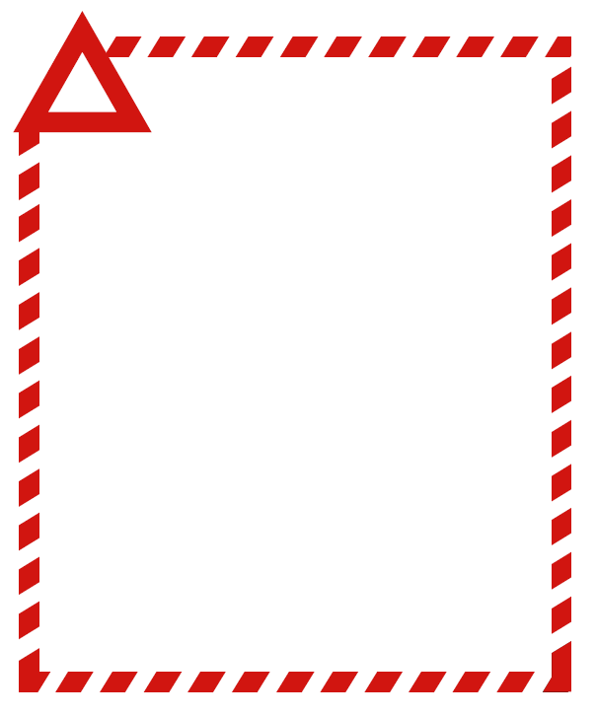

**FOOD RECALL NOTICE**

**ALLERGEN WARNING**

**<Company Name>**

**<Brand Product Name 1> <Pack Details 1>**

<Batch Information 1> <Date Information 1>

**<Brand Product Name 2> <Pack Details 2>**

<Batch Information 1> <Date Information 1>

**<Product Image(s)>**

Attention customers

<Company Name> is recalling the above product(s) due to the presence of an undeclared allergen <name of the allergen>.

If you have an allergy to <name of the allergen> and have purchased this/these product(s) please do not consume. If you have consumed this/these product(s) and have any concerns about your health, seek medical advice.

Consumers with a <name of allergen> allergy should return the product(s) to this store for a full refund (or other consumer advice on recalled products). If you are not allergic or intolerant to (name of allergen) this recall does not affect you.

<Company Name> wishes to apologise to our customers for any inconvenience that this may cause.

<Name>

<Position> (Optional)

<Company Contact Details> (Optional)

Version <#> <dd/mm/yyyy>