Informative title

New Zealand Fisheries Assessment Report 20XX/…..

I.I. Author1,

J.J. Author2,

K.K. Author3

ISSN 1179-5352 (online)

ISBN XXXX (online)

Month 2025

This draft report is not for publication or release; it is presented for consideration by Fisheries New Zealand and Fisheries New Zealand Working Groups. It may contain unpublished data, analyses, and/or conclusions that are subject to change. Data contained in this report should not be cited or used for purposes other than the work of Fisheries New Zealand and its Working Groups without the written permission of Fisheries New Zealand and the authors.

Disclaimer

This document is published by Fisheries New Zealand, a business unit of the Ministry for Primary Industries (MPI). The information in this publication is not government policy. While every effort has been made to ensure the information is accurate, the Ministry for Primary Industries does not accept any responsibility or liability for error of fact, omission, interpretation, or opinion that may be present, nor for the consequence of any decisions based on this information. Any view or opinion expressed does not necessarily represent the view of Fisheries New Zealand or the Ministry for Primary Industries.

Enquiries should be directed to:

Fisheries Science Editor

Fisheries New Zealand

Ministry for Primary Industries

PO Box 2526

Wellington 6140

NEW ZEALAND

Email: [Fisheries-Science.Editor@mpi.govt.nz](mailto:Fisheries-Science.Editor@mpi.govt.nz)

Telephone: 0800 00 83 33

This publication is also available on the Ministry for Primary Industries websites at:

<http://www.mpi.govt.nz/news-and-resources/publications>

<http://fs.fish.govt.nz> go to Document library/Research reports

© Crown Copyright – Fisheries New Zealand

Please cite this report as:

Author1, I.I.; Author2, J.J.; Author3, K.K. (20xx). Informative title. *New Zealand Fisheries Assessment Report 20xx/xx.* xx p.

TABLE OF CONTENTS

EXECUTIVE SUMMARY 1

1 INTRODUCTION 2

2 METHODS 2

3 RESULTS 2

3.1 Results 1 2

3.2 Results 2 3

3.3 Results 3 4

4 DISCUSSION 5

5 POTENTIAL RESEARCH 5

6 FULFILMENT OF BROADER OUTCOMES 6

7 ACKNOWLEDGEMENTS 6

8 REFERENCES 6

9 APPENDIX 1 7

10 APPENDIX 2 7

11 APPENDIX 3 7

**PLAIN LANGUAGE SUMMARY**

This is a summary in language similar to a newspaper level, approximately 10 sentences long explaining in plain language what the project did and what it found out and what is the relevance of the information. Use bullet points if it helps to put across a number of points in a simple way. This will also be used as the Website Summary.

# EXECUTIVE SUMMARY

**Author1, I.I.**[1]**; Author2, J.J.1; Author3, K.K.1 (20xx). Informative title.**

***New Zealand Fisheries Assessment Report* 20xx/xx. xx p.**

An Executive Summary, normally no more than one page, should accompany all reports. It should be intelligible when separated from the rest of the paper, and should not have any undefined abbreviations, equations, or reference citations. It should state the purpose of the paper, describe the investigation on which it is based, state the methods used, and summarise the results and conclusions.

# INTRODUCTION

The Introduction should set the scene fully and clearly. Indicate the reasons why the study was carried out. Any previous work relating to your study should be summarised in a few relevant references. The overall objectives and specific objectives of the commissioned project, and any agreed modifications, must be presented. The wording should reflect that of the contract.

Spell out any abbreviations the first time they are used. Please note that FNZ is not an acceptable abbreviation for Fisheries New Zealand. If you are using a species common name that is derived from Te Reo Māori please spell it correctly, (e.g. Pāua or Pōrae).

In text, cite double authors as Ayling & Cox (1982). Three or more authors should be cited as Constable et al. (1989). Do not put a comma between name and date (e.g., Cooke 1994) except where taxonomic convention requires it. If you cite or include material from a Client Report, ensure that it is in the public domain or that you have the Client’s permission to cite it.

To help your readers, keep the sentences short and straightforward. Paragraphs should be mostly short and they should be focused on one topic. Use precise, familiar words where possible and explain unfamiliar technical terms when they are first used.

# METHODS

This section (and subsections) should provide the geographical and physical setting of the research, describe survey design, sampling methods, and so on, depending on the nature of the project. It is important that any statistical techniques and analytical methods be fully explained (if new) or referenced.

# RESULTS

## Results 1

Here you present your own information and figures without reference to or discussion of other work. Observations, modelling results, and statistical analysis should be clearly presented. Where you have a range of numbers (2021–22, 4–6 g/m2) or page numbers in references, use an en dash like this –, not a hyphen -. Four digit numbers in text are not spaced (e.g., 1234), but five digit ones or longer are (12 345).

Tabular material, maps, and figures are especially important for providing comparative results without resorting to detailed textual descriptions. The tables and figures with their captions should be understandable on their own, and not rely on the supporting text. To assist readers with colour vision deficiency (CVD), use symbol shapes and sizes and a range of intensities to show differences, not just different colours. Ensure that Table or Figure captions are not separated by a page break from the Table or Figure. If a Table continues over a page, ensure that table headings are repeated.

If you reproduce a Figure that was published in another journal, you must get permission from that journal and there may be a fee associated, even if you are the original author of the figure, because it has become the Intellectual Property of the journal.

All material in the FAR including maps must adhere to the Data Confidentiality guidelines. Under the Framework for Government held information, the Ministry for Primary Industries as the Steward of government-held data and information, is required to adhere to the principle that personal, confidential and classified data and information are protected. This includes the principle that the statistical results produced do not contain any results that disclose individually identifiable information. We are obliged to protect confidentiality by ensuring that details about individual people, businesses, or organisations are not identifiable, and cannot be deduced.

Specifically, Commercial Catch and Effort data and Observer data may only be published in summarised form where:

* information that identifies specific vessels or people is removed, including any unique system identifiers of vessels or people (including companies);
* vessel attributes (e.g., length, breadth, tonnage, nationality, etc.) are removed; and
* data is grouped such that no group contains data from fewer than three permit holders.

One of the key tools that we use for doing this is the “three permit holder” rule. If we were to release data (for example a map), that has data from only two permit holders in one cell then each of those two permit holders can deduce exactly what the other permit holder did by subtracting off their own values and we would have breached our stewardship obligations.

To protect the confidentiality of microdata — and where necessary, larger datasets —data.govt.nz recommend the use of one or more of these statistical methods.

* Perturbation – adding random noise to data outputs (e.g. jittering points on a map, rounding, truncating, using larger symbols).
* Aggregation – combining data (e.g. making the spatial or temporal resolution larger so that you have data from at least three permit holders in each cell).
* Suppression – deleting the plots from the manuscript (and for example just describing in words what you want the readers to know).
* Limiting data access – for example, not publishing the plots on the version of the manuscript that goes to the website (possibly having two different versions, one held internally only).

Explain in the document how you used these methods to ensure Data Confidentiality.

Alternatively, you can get permission from the people whose data you are trying to protect, but you would need ALL of the permit holders individually, which is not easy, especially when the data has been collected over a long time period.

## Results 2

Some results are shown in Table 1 below. This is from the 2010–11 fishing year. Note that figure captions follow the same formatting as the table caption in the example below (with an indent of 1.75 cm).

Table 1: Mean catch rates (kg km-1) of pre-recruit (< 32 cm), recruit (> 32 cm), and all orange roughy by area and depth range for 2010‒11.

|  |  |  |  |  |  |  |  |  |  |  |  |
| --- | --- | --- | --- | --- | --- | --- | --- | --- | --- | --- | --- |
| Depth |  |  |  | | | | | | Area code* | | |
| range (m) |  | Size | KAIK | CLAR | MADD | PORT | RICH | TOLA | | EAST | Total |
|  |  |  |  |  |  |  |  |  | |  |  |
| 600–800 |  | Pre-recruit | 14.5 | 36.3 | 5.3 | 4.4 | 0.1 | 0.1 | | 0.6 | 7.1 |
|  |  | Recruit | 0.6 | 7.8 | 0.7 | 3.2 | 12.7 | 0.6 | | 0.0 | 3.4 |
|  |  | All fish | 15.1 | 44.1 | 5.0 | 7.6 | 12.8 | 0.7 | | 0.6 | 10.5 |
|  |  |  |  |  |  |  |  |  | |  |  |
| 800–1000 |  | Pre-recruit | 1 177.3 | 20.3 | 15.9 | 4.8 | 3.5 | 0.3 | | 2.84 | 2.3 |
|  |  | Recruit | 35.3 | 0.5 | 18.4 | 1.3 | 12.8 | 1.8 | | 1.5 | 11.3 |
|  |  | All fish | 1 212.6 | 20.8 | 34.3 | 6.1 | 16.3 | 2.1 | | 4.3 | 54.6 |

* See Figure X for spatial representation of the areas.

## Results 3

Figure 1 and Figure 2 show examples of how spatial catch distributions (Datta et al. 2024) and catch distributions (Holmes & McGregor 2024) can be presented while meeting data confidentiality requirements.

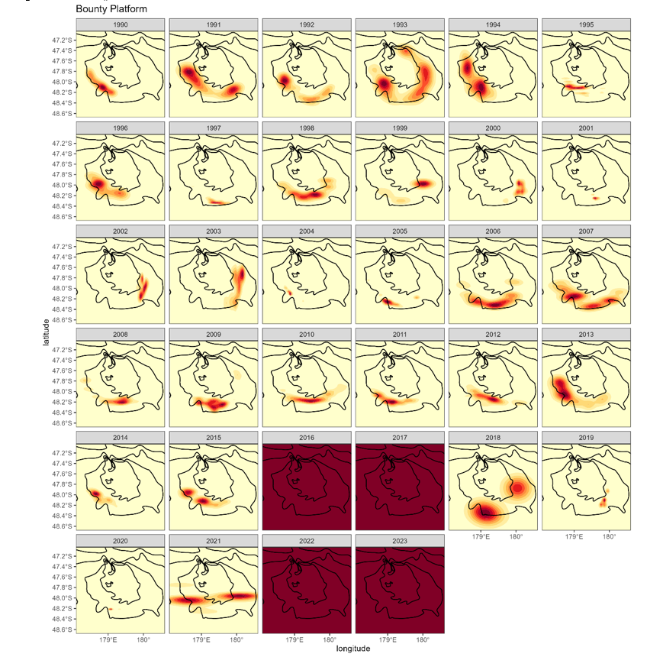

Figure 1: Spatial catch distribution of southern blue whiting on Bounty Platform (coordinates show the location of the start of each tow), over the fishing years 1990–91 to 2023–24 inclusive (labelled by year beginning). Darker red shades indicate higher catches. Data not plotted for fishing years 2016, 2017, 2022 and 2023 due to data confidentiality requirements.

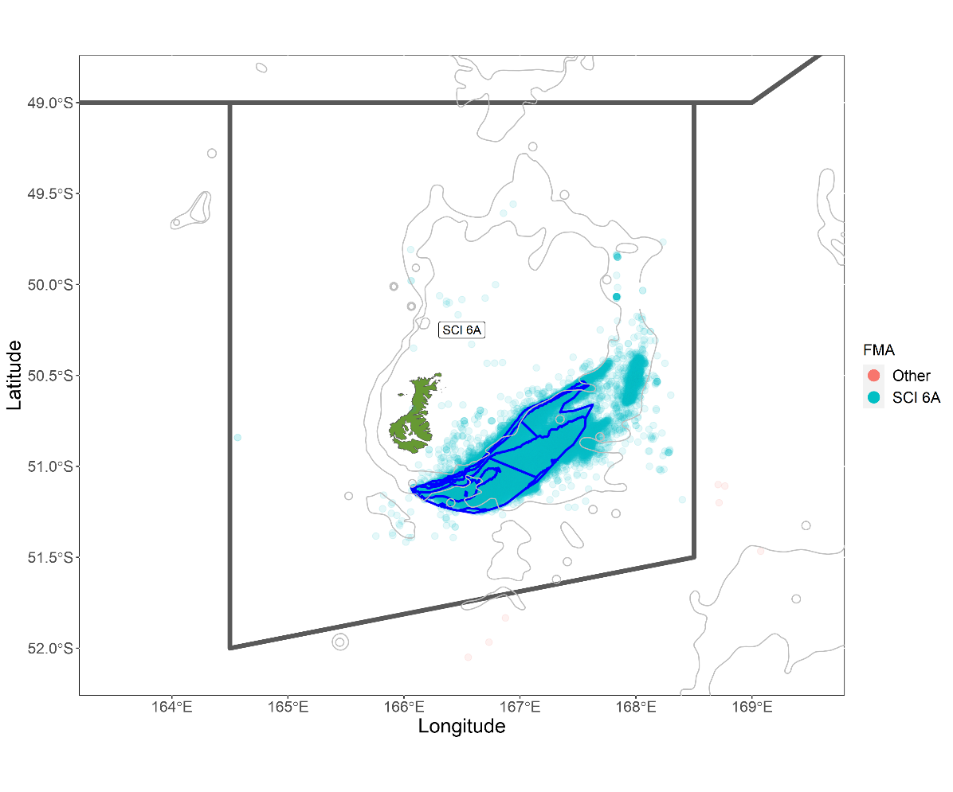

Figure 2: Spatial distribution of the scampi fishery within management area SCI 6A since 1988–89. Each dot shows the midpoint of one or more tows recorded on TCEPRs or ERS with scampi as the target species. Symbols are semi-transparent such that colour intensity builds with successive overlapping tows. The boundaries of the scampi survey strata are shown in blue, the boundary of the SCI 6A management area in black and 200 and 500 m depth contours in grey.

# DISCUSSION

The results of your study are related in this section to those of previous studies. The results should be interpreted with the support of evidence or suitable references. Anomalous or unexpected results should be explained. Any conclusions offered should be listed clearly at the end of the Discussion, but these should be limited to scientific questions, and not include opinions about potential management implications.

# POTENTIAL RESEARCH

This is an optional section to list, at a conceptual level, potential research of relevance to the subject of this report. It should include Working Group and Plenary recommendations on future research. It may contain relative judgements about the priority of research recommendations i.e., this research is deemed higher priority than that or should ideally occur before that (because the latter will be informed by the former). This section should not contain absolute judgements about priority, i.e., essential, or high priority.

# FULFILMENT OF BROADER OUTCOMES

As required under Government Procurement rules[2], Fisheries New Zealand considered broader outcomes (secondary benefits such as environmental, social, economic, or cultural benefits) that would be generated by this project. The following broader outcomes were delivered.

* List what you have delivered in terms of broader outcome A (if applicable).
* List what you have delivered in terms of broader outcomes B (if applicable).
* List what you have delivered in terms of broader outcomes C (if applicable).

# ACKNOWLEDGEMENTS

Here you can list supporting institutions and the names (untitled) and the affiliations of people who have assisted in some way with your research or manuscript development. You must acknowledge Fisheries New Zealand funding and provide the project code; e.g., this work was completed under Objective XX of Fisheries New Zealand project XXX20xx-xx. Please also thank the Fisheries New Zealand Project Scientist for guiding the project and reviewing the document (and any other significant contributions they may have made) and the appropriate Fisheries New Zealand Working Group for useful suggestions and contributions.

# REFERENCES

This section should contain only references cited in the FAR and is not intended to be a bibliography. Authors are responsible for the accuracy of the references. Citations are to follow the Harvard System, i.e., in the text they are to be by author's name and year of publication, and at the end of the paper in alphabetical order of authors' surnames. Works by the same author and published in the same year are to be distinguished by letters appended to the year. Spell out Journal names in full. Book names and journal names should be italicised. Publisher names should not be italicised, neither should. unpublished work or drafts. Use references as formatted below:

Ayling, T.; Cox, G. (1982). *Collins guide to the sea fishes of New Zealand*. Collins, Auckland. 343 p.

Constable, J.D.; Scott, P.H.; Connor, M.A. (1989). Fixed bed nitrification as a potential means of enhancing nitrogen removal rates in a sewage lagoon. *In*: Australian Water and Wastewater Association, Proceedings of the 13th Federal Convention, pp. 192–196. 6–10 March 1989, Canberra.

Cooke, J.G. (1994). Nutrient transformations in a natural wetland receiving sewage effluent and the implications for waste treatment. *Water Science and Technology 29 (4)*: 209–217.

Datta, S.; Hart, A.; Barnes, T.; Sutton, C.; Spong, K. (2024). Catch-at-age for southern blue whiting (*Micromesistius australis*) during the 2023–24 fishing year. *New Zealand Fisheries Assessment Report 2024/73*. 21 p.

Holmes, S.J.; McGregor, V.L. (2024). Characterisation, standardised CPUE, and assessment input data for scampi (*Metanephrops challengeri*) at the Auckland Islands (SCI 6A) for 1989–90 to 2022–23. *New Zealand Fisheries Assessment Report 2024/72*. 61 p.

Pearson, T.H.; Black, K.D. (2001). The environmental impact of marine fish cage culture. *In*: Black, K.D. (Ed.). *Environmental impacts of aquaculture*, pp. 1–31. Academic Press, Sheffield.

# APPENDIX 1

# APPENDIX 2

# APPENDIX 3

1. Add affiliation for each author at the time the work was undertaken.
2. <https://www.procurement.govt.nz/procurement/principles-charter-and-rules/government-procurement-rules/planning-your-procurement/broader-outcomes/>