Air Container Report
Use this template to record contamination and then report it on the Container Checks website, https://containerchecks.maf.govt.nz.
Freight
Name of Transitional Facility______________ ATF number ___________________ Transitional Facility Operator _________________________
Supervising Accredited Person (AP) __________________ MPI AP Number_______________ Accredited Person Signature__________________
Baggage Handling
Name of Baggage Handling Service Provider ____________________
Supervising Accredited Person (AP) ________________ MPI AP Number _______________ Accredited Person Signature___________________
Date | Flight (if known) | Origin of freight/  baggage | No. of Air cans/ULDs from each flight | ULD or flatrack No. | Type and amount of contaminant (see Contamination Charts) | Wood packaging ISPM marked?  Yes/No | Where  in the container?  (Inside, Outside) | Person finding contamination or AP number
(Note type of contamination and location in ULD/flatrack etc.)
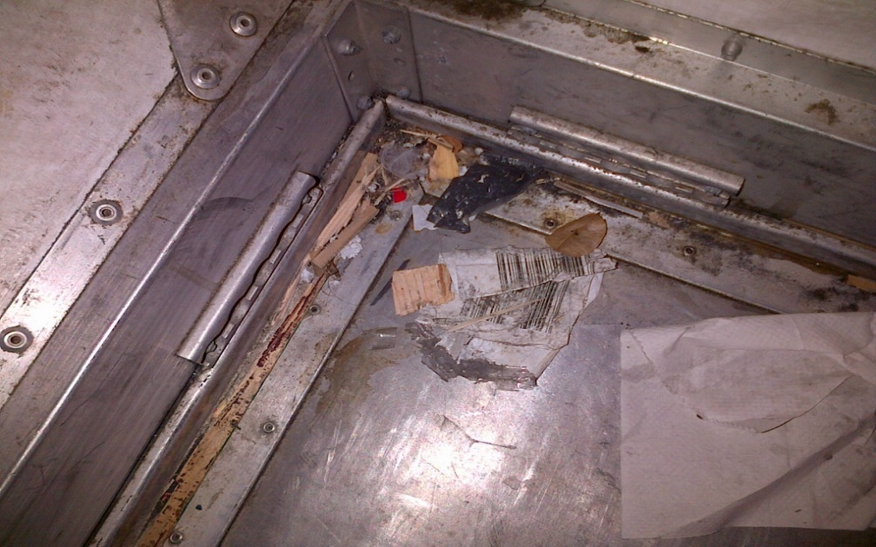
Example
Date | Flight (if known) | Origin of freight/baggage | No. of Air cans/ULD’s from each flight | ULD or flatrack No. | Type and amount of contaminant (see Contamination Charts) | Wood packaging ISPM marked?  Yes/No | Where  in the container?  (Inside, Outside) | Person finding contamination or AP number
28/02/2018 | SQ111 | Brisbane | 17 | AK121 | Leaves (3), feather, wood (packing) | Unknown | I, on floor | J.Kirwan

Report the contamination on the Container Checks website, https://containerchecks.maf.govt.nz.
If the website is not available, email this form through to aklitbops@mpi.govt.nz with ‘Air Container Report’ in the subject line.
Please note if any live pests are found contact 0800 80 99 66

